Ancient Egypt Numbers

With an adult visit the website link below and have fun carrying out the number challenge!

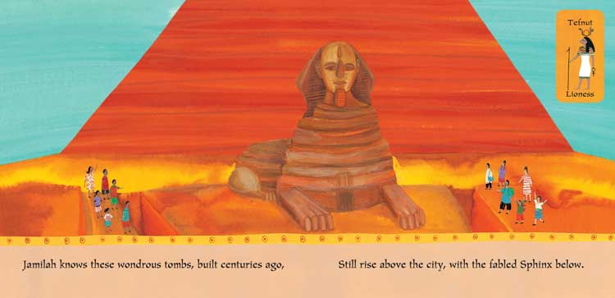

http://www.childrensuniversity.manchester.ac.uk/learning-activities/history/ancient-egypt/the-egyptian-number-system/

