Use your creative mind to write a short news article detailing how the snow has impacted on your local area.

Think about:
- Travel chaos
- Heating costs
- Impact on the elderly
- Accidents and incidents
- Closure of schools
- Fun

Remember to include quotes from an eye witness and ensure you have included the 5W’s. (Who. What. Where. When.Why.)

Below you will find a template for your news article, if you wish to use it.

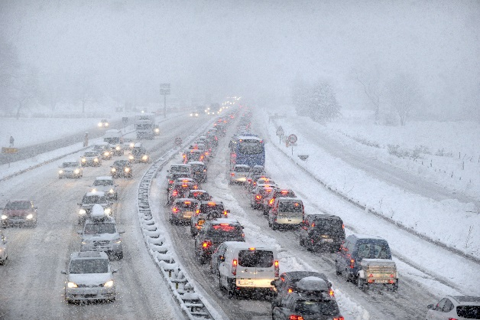

THE REIGATE ST MARYS EXPRESS
www.burstowexpress.com THE PEOPLE’S FAVOURITE NEWSPAPER £1

………………………………………………………..

………………………………………………………..

……………………………………………………..…

………………………………………………………..

………………………………………………………..

………………………………………………………..

………………………………………………………..

……………………………………………………..…

………………………………………………………..

………………………………………………………..

………………………………………………………..

………………………………………………………..

………………………………

…………………………........

………………………………

………………………………

………………………………

………………………………

………………………………

………………………………

………………………………

…………………………………………………………..

…………………………………………………………..

…………………………………………………………..

…………………………………………………………..

…………………………………………………………..

…………………………………………………………..

…………………………………………………………..

…………………………………………………………..

…………………………………………………………..

…………………………………………………………..

…………………………………………………………..

…………………………………………………………..

…………………………………….

…………………………………….

…………………………………….

…………………………………….

…………………………………….

…………………………………….

…………………………………….

…………………………………….

…………………………………….

…………………………………….

………………………………………………………….

…………………………………………………………..

…………………………………………………………..

…………………………………………………………..

…………………………………………………………..

………………………………………………………….

………………………………………………………….

………………………………………………………….

…………………………………………………………..

…………………………………………………………..

…………………………………………………………..

…………………………………………………………..

…………………………………….

…………………………………….

…………………………………….

…………………………………….

…………………………………….

…………………………………….

…………………………………….

…………………………………….

…………………………………….

