***Solve these word problems. Show how you have worked it out.***

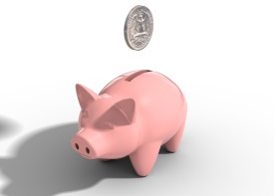Tom had 26 coins in a piggy bank. His dad gave him 6 more coins as pocket money. How many coins does he have now?

C:\Users\rlove1.306\AppData\Local\Microsoft\Windows\Temporary Internet Files\Content.IE5\PIEO9LZ1\MC900264268[1].wmfA packet has 6 sweets inside. How many sweets would there be in 3 packets?

C:\Users\rlove1.306\AppData\Local\Microsoft\Windows\Temporary Internet Files\Content.IE5\PIEO9LZ1\MC900264268[1].wmf

C:\Users\rlove1.306\AppData\Local\Microsoft\Windows\Temporary Internet Files\Content.IE5\97IP5H6K\MC900112658[1].wmf

There are 30 biscuits on a plate. 13 get eaten. How many are left now?

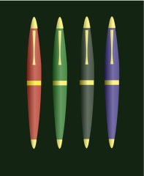Ben has 8 pens. Sam has 10 pens. How many pens do they have altogether?

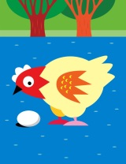Some hens lay 6 eggs, 4 eggs and 8 eggs. How many eggs altogether?

Chip made 12 cakes. Half of the cakes got eaten. How many are left?

C:\Users\rlove1.306\AppData\Local\Microsoft\Windows\Temporary Internet Files\Content.IE5\7EUPCVGK\MC900415074[1].wmfRosie had 20p. She spent 7p on a toy. How much money will she have left?

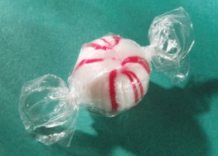

Chews cost 5p. How much would 5 chews cost?